ASSIGNMENT4

**COMPILER CONSTRUCTION**

**Exercise 1.** Write a program to enter 2 integers a and b and print the number of integers between a and b.

**Exercise 2.**Write a program to enter 3 integers. Display the number of values greater than 20 and less than 100.

**Exercise 3.**Enter an array (no more than 10 elements) of integers, calculate and display the number of elements in the array less than the first element.

**Exercise 4.** Write a program in KPL to read n integers (n ≤ 10) into array A , print the input values from last to first ,then print the sum of the elements.

**Exercise 5.**Matrix L is a *lower triangular matrix* if it is a square matrix which all entries above the main diagonal are zero. For example,

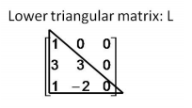

Write a KPL program to read elements in a matrix and check whether the matrix is lower triangular matrix or not. The program prints 1 if the matrix is lower triangular, otherwise it prints 0.

A := array(.3.) of integer